**SSL Certificate on Nginx Web Server**

First we go to nginx directory and create a directory ssl

Create a file named **ssl-info.txt** for SSL certificate information.

## cd /etc/nginx

## sudo mkdir /etc/nginx/ssl

## cd /etc/nginx/ssl

## sudo nano ssl-info.txt

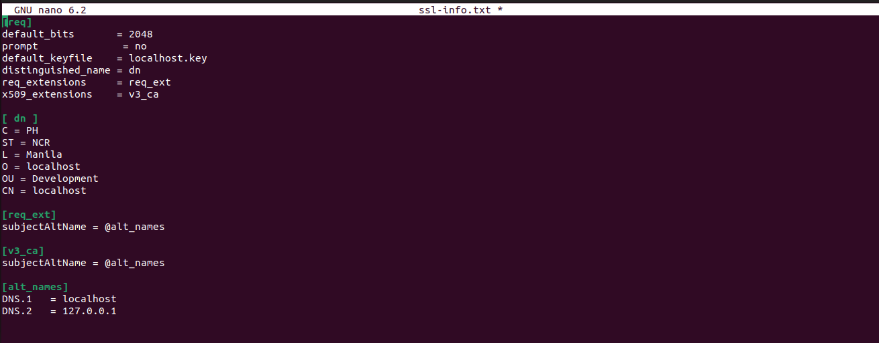

2. Generate SSL Certificate

sudo openssl req -x509 -nodes -days 3652 -newkey rsa:2048 -keyout localhost.key -out localhost.crt -config ssl-info.txt

3. make a backup file of default and Configure Nginx Add the SSL configurations to the Nginx default configuration

> cd /etc/nginx/sites-available

sudo cp default default.bak

sudo vi /etc/nginx/sites-available/default

*#ssl conf which we add in nginx default file*

*listen 443 ssl http2;*

*listen [::]:443 ssl http2;*

*ssl_certificate /etc/nginx/ssl/localhost.crt  
 ssl_certificate_key /etc/nginx/ssl/localhost.key;  
 ssl_protocols TLSv1.2 TLSv1.1 TLSv1;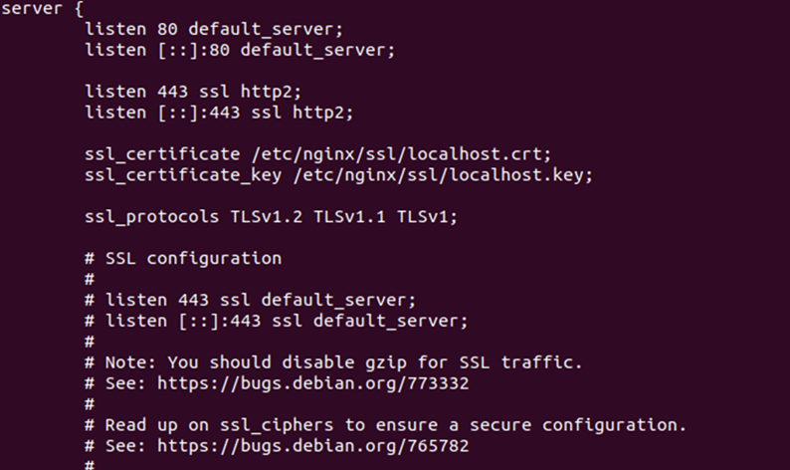*

finally reload nginx service and now Nginx is configured to use the generated SSL certificate for HTTPS connections. Open browser and put your Ip to test that nginx use 433 port https

* sudo service nginx reload

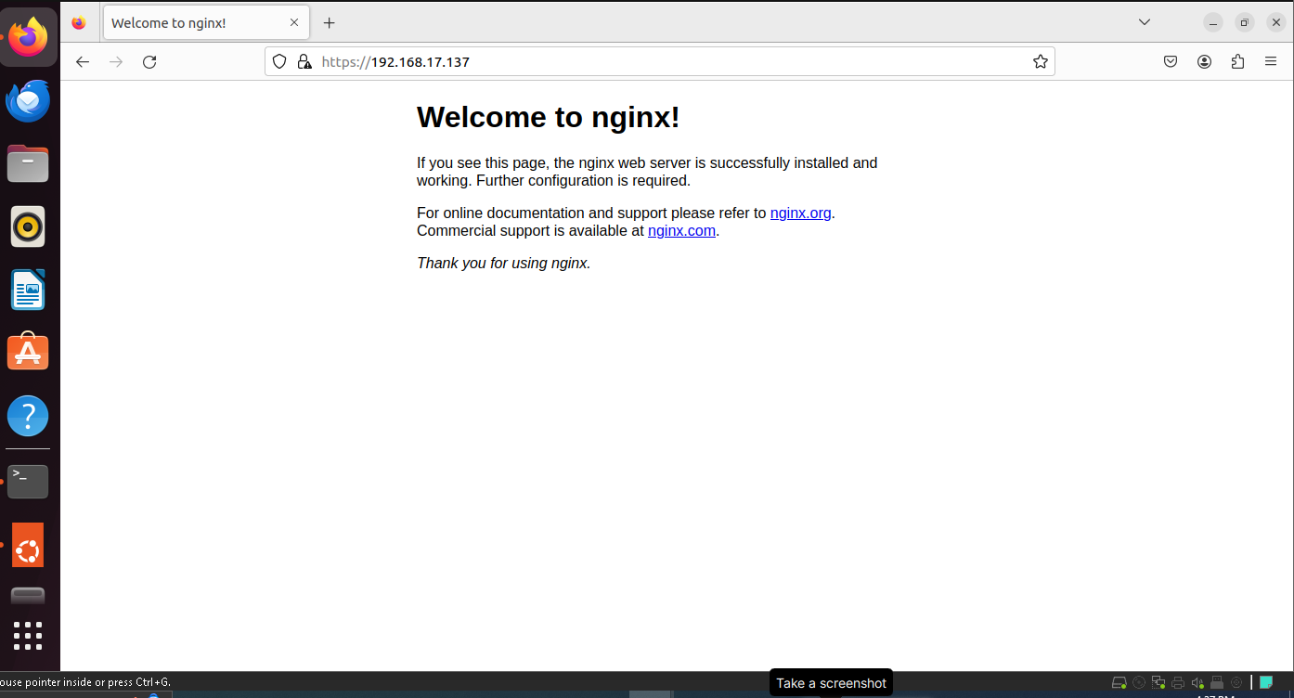

# done >>>>>>>>>>>>>>>>>>>>>>>>>>>>>>>>>>>>>>>>>>>>>>